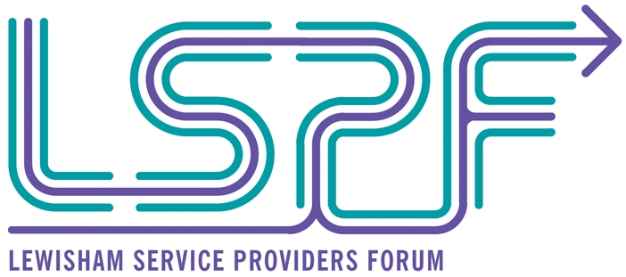

Lewisham Service Providers Forum
Memorandum of Understanding

Purpose:-
The core objective of the Local Service Providers Forum is to improve local referral protocols.

This will be achieved through greater partnership working, sharing best practice, training for front-line staff and capacity building for local service providers.

The forum brings together partners from the public, private and third sector with a role to play in supporting local residents into training and employment.

The Lewisham Service Providers Forum is facilitated by Economic Development, London Borough of Lewisham.

This forum supports Lewisham’s Sustainable Community Strategy 2008 -2020 - Shaping Our Future

- Ambitious and achieving – Encourage and facilitate access to education, training and employment opportunities for all out citizens
- Dynamic and Prosperous – Increase access to the number of quality and range of employment opportunities.

Outcomes:- Key outcomes the forum aims to achieve are:-

Establishment of a local service provider forum – Strengthening partnership links, up-skilling staff, capacity building local organisations and creating more effective ‘journey into employment’ referral protocols for Lewisham residents aged 19 years plus.

Improved referrals – Greater number of Lewisham residents referred to services tailored to their individual needs and improved tracking of referrals.

Training of front-line and service delivery staff – Staff highly skilled at delivering services at each stage of the ‘journey into employment’ and greater understanding and knowledge of referral partners, services on offer and how to monitor and track referrals.

And in turn this will achieve:-

Greater take-up of services – Increased number of Lewisham residents taking up other services to support their individual journey into employment.

Sustained progression routes for clients – Greater number of Lewisham residents maintaining progression on their journey into employment.

Reduction in the levels of worklessness within Lewisham – Greater number of Lewisham residents progressing into economic activity than if no additional activity had taken place.
Implementation:-
The forum is managed by the Employment Development Manager, Economic Development, LB Lewisham. They maintain a directory of local service providers engaged in the forum; facilitate bi-monthly forum meetings and events; publish monthly forum newsletters and administer the LSPF Capacity Building small grant fund.

Members of the forum agree a programme of activities including themes and topics for meetings, networking events and workshops.

Specialist support agencies are invited to present at meetings and workshops to raise awareness of how clients with specific needs can be supported. For example, this may include support available for lone parents; working with clients with learning disabilities or mental health issues; working with ex-offenders or clients with drug and alcohol addictions; support available for homeless people.

Workshops are also held to raise awareness of employment support provision available within the borough which local specialist agencies can refer their clients to.

Members of the forum will represent the group at events, seminars, conferences and training workshops and feed back at the regular forum meetings.

Local service providers will receive capacity building support to help them improve their service delivery and referrals and to support their sustainability.

Membership:-
This is a forum for all organisations providing services to Lewisham residents with a role to play in supporting people to access training and employment opportunities.

New members to the forum are welcomed. Enquiries should be made to Joanna Huxton, Employment Development Manager, LB Lewisham.

Partnership Principles:-
Members of the forum agree to the following partnership principles:-
- Value each other
- Recognise and respect each other’s remit
- Be clear about shared aims and working arrangements
- Share information and maintain good communication links
- Commit to providing quality services
- Referrals
- Signposting
- Support the most disadvantaged
- Ensure equality of access and opportunity

Nature of this agreement:-
This is not a legally binding agreement but a commitment made by members of the forum.

The MOU shall be reviewed on a annual basis.

